Curriculum/Instruction and Assessment Synthesis
McKenna Walsh
University of Mary

Curriculum/Instruction and Assessment Synthesis
Throughout the semester, I have created and learned a great deal about the content taught within this course. This paper highlights each of the tools I have created which I will be able to utilize in my future classroom. Furthermore, I will discuss how each theme will aid me later as a teacher.
The Effective Teacher
I believe that the best way to learn is by observing, imitating, and eventually adapting and creating your own way of teaching. With that being said, you must observe someone who is good at what they do, if not great; this is how one is able to become an effective teacher. As stated throughout Appendix A, I have been blessed with observing and imitating my mother. I have taken what I have seen her do while teaching and tried it within my various opportunities teaching students. From that point, I learn what works best for me and my personality and have formulated my own way of teaching. I hope to continue to learn from other master teachers and then adapt their strategies into my own. I believe this is the process of becoming an effective teacher.
Understanding Your Students
One of the primary ideas in understanding your students is understanding their learning styles. Learning styles can be described through multiple intelligences (MI). Appendix B is a lesson plan stressing the importance of MI throughout by ensuring that the learning activities are differentiated to allow each student to learn in the best possible way. When I become a teacher, I aspire to always keep this concept in mind. If I can make a student’s learning process easier by catering to their learning styles, I see no reason not to. MI are a wonderful way to truly understand your students and guarantee they eventually come to love learning.
Classroom Management
I created a “Welcome to Second Grade” PowerPoint, see Appendix C, as an artifact used to help me with my classroom management. It provides the students with procedures and rules needed to get the school year started. I limited the PowerPoint to about ten slides so that it does not overwhelm the students on the first day. Each rule or procedure will help my classroom run more smoothly. The hope is that eventually the students will be so familiar with theses that they will not even think twice about it. This is definitely a strategy I will be using in my future classroom.
Goals, Standards, and Objectives
I believe it is extremely important for the information being taught to your students aligns with the standards and objectives. I also think it is important to make goals as a class for your students, and even encourage students to do so individually. See Appendix D for information on the Common Core Standards. It is critical for teachers to be comfortable with the standards so that they can teach effectively. Appendix D also includes information on why Common Core is being used and will help to know what to say when parents or others question or criticize them. I intend on using this information in that way. On top of having a good understanding of the standards for teaching, I should also be knowledgeable about where they came from and why we use them.
Unit and Lesson Planning
Within this course, I created an interdisciplinary unit plan – see Appendix E. This is a great resource for my future classroom. It pushed me to think about each subject more deeply and provoked me to discover ways they can all be connected. I really like interdisciplinary units because they help create a stronger connection for the students. I plan to create these as often as possible in my future classroom. I believe they encourage project-based learning which is a strategy I want to use often when I become a teacher.
Technology Integration in Instruction
Technology is something that is only becoming more prominent with time. Using it within education makes learning more inviting and interactive. Appendix F is a lesson plan integrated with several aspects of technology. We live in a world where technology is all around, rather than fight that, I plan to embrace it. Technology is something kids should be comfortable with; therefore, I want to use it as much as possible. It can be used for online games, PowerPoint projects, and writing papers. You can also use online software such as PowToon to allow your students to express themselves in different ways with their assignments.
Questioning Strategies
Questioning is a key component of teaching; if you think about it, teaching is mostly asking students different questions. There are even specific strategies focused on guiding students to the correct answer by continuously questioning them, such as the Socratic Method. Thus, it is important for teachers to have questions pre-planned so that they can keep a discussion going in the way they want to and foster deeper thought. Appendix H depicts levels of questioning that can help you guide students through a standard. Appendix G categorizes questions into different purposes which can help you know why you are asking your students these questions. Both of these strategies will be beneficial to me as a future teacher. I plan to implement them by breaking down my standards into levels of questioning and then determining the purpose of the questions I plan to ask my students.
Teaching Strategies for Direct Instruction
While direct instruction is not the most welcome thing in today’s education system, occasionally it is inevitable. See Appendix I for an example of a direct instruction lesson plan. I hope to not use direct instruction very often in my future classroom; however, I understand that that cannot always be the case. When direct instruction is needed, I hope to still make it engaging by including my students through discussion and questioning.
Teaching Strategies for Indirect Instruction
Indirect instruction is a strategy everyone in education is moving towards and using. It pushes things like student-led discussion and project-based learning. Appendix J is an indirect math lesson plan. Its intent is to aid students in discovering liquid volumes and how to measure them. I actually witnessed this lesson in my practicum experience and fell in love with the process. It was inspiring to watch how each student made the connections the teacher was hinting at with her directly telling them. I intend to implement indirect instruction as much as possible when I become a teacher, especially because I feel I have seen education through both lights. I was part of an education system where all teachers did was lecture; now that I am studying education I see the movement towards indirect instruction, and I could not be more excited to teach in this way.
Assessing Learning
With the lack of direct instruction, education is also moving away from assessment in the format most of us remember it. However, sometimes there is just no way around it. Included in Appendix K is a unit test derived from my interdisciplinary unit plan (Appendix E). Ideally, I would not give a test like this to a group of third grade students. Instead, I would most likely give each section on different days and spread out over a week or two, depending on how long we spent on the unit. Also included is Appendix L which is a test blueprint of my unit test. This was a really neat tool because it allowed me to break down my test and really focus on what kind of questions I would be asking my students and what level I am potentially assessing them at. This will be a tool I will try to use as often as possible, specifically on more important tests that I know the students need to have a deep understanding on that specific topic.
Conclusion
I believe that each of the tools and strategies discussed above will all be utilized in my classroom someday. I appreciate each one of them and believe they will serve specific and meaningful purposes. When I picture my classroom, along with the use of all these tools, I see a large rectangle of desks surrounding the carpet with a opening at the front facing the board. This will be great for large whole group discussions and lessons. I want to allow my students to have different chair options as well (ball-chairs, stools, rolling chairs, cushions for regular chairs, etc.). I also envision a few large tables and a horseshoe-shaped table with stools ideal for group work and mini lessons. Off in the corner I would like to have my desk that will also section off a part of the classroom near the window that will be made the reading corner with bean bag chairs, bookshelves, and white Christmas lights hanging. Within in the corner, I would like to have a highlighted book shelf filled with books relating to our theme or topic. On the whiteboard regularly would be daily objectives, calendar, and our class goal for the month.

Appendix A
Reflection Paper
Quintilian discusses how influential the people close to you, teachers specifically, can be so incredibly influential in our lives. He mentions that they feed us nutritiously with love and reverence. All my life, I have formed close relationships with many teachers. I have truly appreciated all of the knowledge they have given to me pertaining not only to the subject they taught, but also in regards to the life-long skills relating to human character. I also would agree that we tend to imitate those who we like. I think this comes from the swift, first impressions we get when we are introduced to someone and we walk away thinking, “Wow, I like them!” And from that point, they remain in our minds as people we would like to be more like because you have found a quality you like about them.
An individual in my life that has become not only someone I would like to imitate, but also someone who feeds my mind with love and reverence, is my mother. My mom has been a teacher for over twenty years and she is an amazing person. She has inspired me in so many ways throughout my life that I cannot begin to discuss all of them. However, I would like to mention a few. First and foremost, my mom has inspired me to be a kind and loving person. She also is a constant example of how hard work and dedication can really pay off. And lastly my mom is one of the first reasons I decided to become an educator.
Throughout my life, I have struggled with always being kind and loving, especially when first getting to know someone. My mom has always excelled in this area and people just naturally like her. I aim to imitate her in this way every day. This kindness and love radiates from her and positively affects every person she meets, and is a major attribute to have as a teacher. I believe this helps her to feed her students minds with love and reverence and, also, she leads them by example in hopes that they will imitate her.
She has also provided me with being hardworking and determined. When I was finishing high school, my mom was working on getting her Master’s degree. While working full time, and taking care of my siblings and me, she still managed to finish grad school. Sometimes we would work on homework together, and I would realize how devoted my mom was to get this done. She would encourage me while I was doing my homework and never went to bed until we were both finished. I always appreciated this and I believe that it made me want to be even more like her.
When I finally decided to become a teacher, I knew exactly who I wanted to imitate. My mom has always been a phenomenal teacher and her students and their parents always loved her. As I grew up, I found more and more things about my mom that were worthy of imitating. As I prepare to become an educator, I hope to be half as great a teacher as my mom is. Furthermore, she makes me want to be an excellent educator – to make her proud and to prove to myself that I can do it, as well.
In conclusion, I believe that I definitely imitate my mom because I “like,” love, and admire her. I also believe that her knowledge and personality feeds my mind. The advice and help I have received from my mother have been essential in my development as a person, student, and future teacher.

Appendix B
McKenna Walsh
EDU 320
Grade Level: 2nd
Subject Area: Science
Materials Needed (for a class size of 20): 20 small plants in pots, 20 labels, 20 markers

STANDARDS
- 2-LS2-1 Plan and conduct an investigation to determine if plants need sunlight and water to grow
- W.2.7 Participate in shared research and writing projects (e.g., read a number of book on a single topic to produce a report; record science observations).
- W.2.8 Recall information from experiences or gather information from provided sources to answer a question.
- MP.2 Reason abstractly and quantitatively.
- MP.5 Use appropriate tools strategically.
OBJECTIVES
- Students will plan, design, and construct an experiment.
- Students will conduct an experiment using the scientific method.
- Students will understand how plants grow, and what they need to survive.
- Students will test solutions and answer questions.
- Students will analyze data collected from the experiment.
- Students will compare and contrast the results of the experiment between the variables.
LEARNING ACTIVITIES
- Bring all children to carpet
- Ask them to think about what they know about plants quietly for a minute (intrapersonal)
  - Create a KWL chart on a large Post It paper
- Ask students to share things they have thought of about plants (interpersonal)
- Direct their thinking to things that keep plants alive (visual-spatial)
  - Label chart “Know” and “Want to Know” – later add “Learned”
- Have students tell you things the plants need to stay alive and what will kill them. (interpersonal)
  - Write their shared thoughts in the correct area of the chart
- Remind students of the scientific method that we learned about last week.
  - Have them share the steps.
    - First, have them find someone they are not sitting next to to share steps with. (bodily-kinesthetic, interpersonal)
    - Then, have them volunteer to share aloud
  - Write these down on the white board so they can be referenced later on during the experiment. (visual-spatial)
    - Ask a Question, Do Background Research, Construct a Hypothesis, Test Hypothesis by Doing an Experiment, Analyze Data and Draw a Conclusion, Communicate Results
  - Make sure students understand and remember what each step means and consists of.
- Direct students to develop the question: “Do plants need sunlight and water to survive?”
  - For the sake of this project and time, we will say that the guided discussion, prior learning/knowledge on plants, and brainstorming will serve as the research portion.
- Have students do a turn and talk with their elbow-partners (interpersonal)
  - Tell them to talk about what they “hypothesize”/what they think is going to happen.
- Construct a hypothesis with the students and write on the board to reference at the end of the experiment
  - It should follow a “If ________, then _________ will happen.” format.
- Assign students into 4 groups of 5 and seat them at tables accordingly.
- Pass out a pot to each person. Have “helpers” help you pass them out. (bodily-kinesthetic)
  - Give each student a sticky label to put on their pot, along with a marker
  - Have them label with the correct abbreviation and their initials (visual-spatial)
    - Sun & Water – SW
    - Only Sun – S
    - Only Water – W
    - No Sun OR Water – NSW
  - Write these on the board. Each group of 5 should be labeled the same. This way, there are multiple plants undergoing the same experiment, which gives us a better average and less error. Explain this concept to students.
    - First, ask students why they think we are doing this? Do a turn-and-talk (interpersonal)
    - Bring back together
    - Ask someone to share
    - Go over correct answer
- Put all pots in appropriate environments. Helpers can do this (bodily-kinesthetic)
  - W and NSW should go in a dark cupboard
  - SW and S should go near a sunny window
  - Be sure the plants that are supposed to get watered, get watered every other day.
- Every week students should fill out the worksheet attached
  - This will help later when they reach a conclusion
- After about 3 weeks, have students compare their observations
  - Each group should come up and share with the class characteristics of their plants.
- As a class, discuss and develop a conclusion.
  - They should either accept or reject their hypothesis and come up with a conclusion
  - This should be done through a big class discussion. Try using the Socratic method to lead students to correct conclusion without giving it to them directly.
ASSESSMENT
- Have students compile all of their data and results
- Have them walk around the classroom and share what their observations and conclusions were. (bodily-kinesthetic, interpersonal)
  - Have them discuss things they could do differently or more effectively.
- Have them return to their seats
  - Silently, direct students to write a reflection paper that they will turn in. This should include thoughts about the experiment, how they used the scientific method, and what they learned (intrapersonal)
- Go back to the chart and add a “What you learned” column. Crosscheck it with the “What you want to learn” column. (interpersonal)

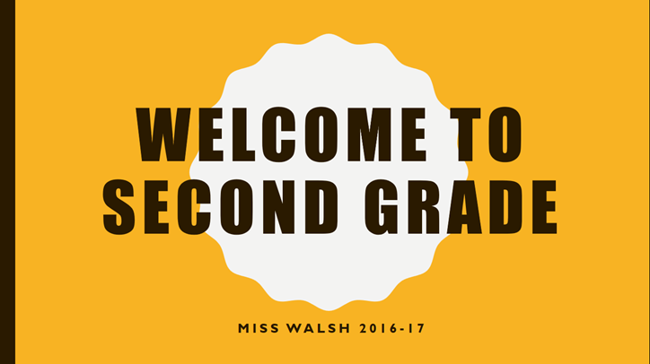
Appendix C

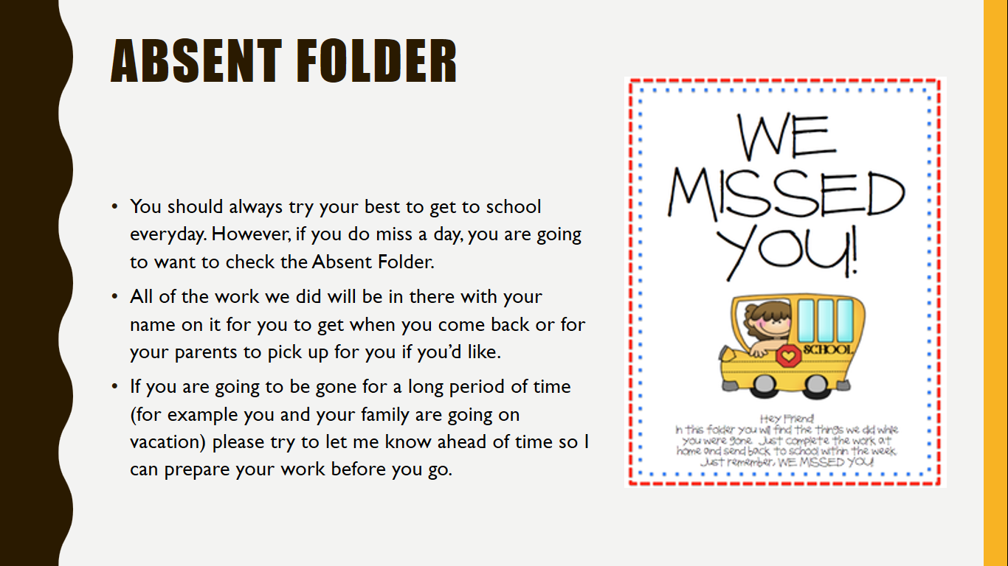

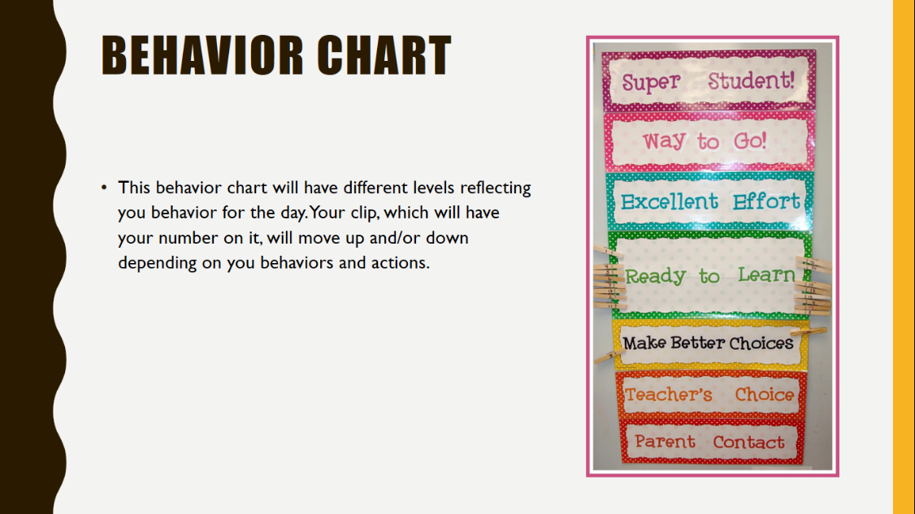
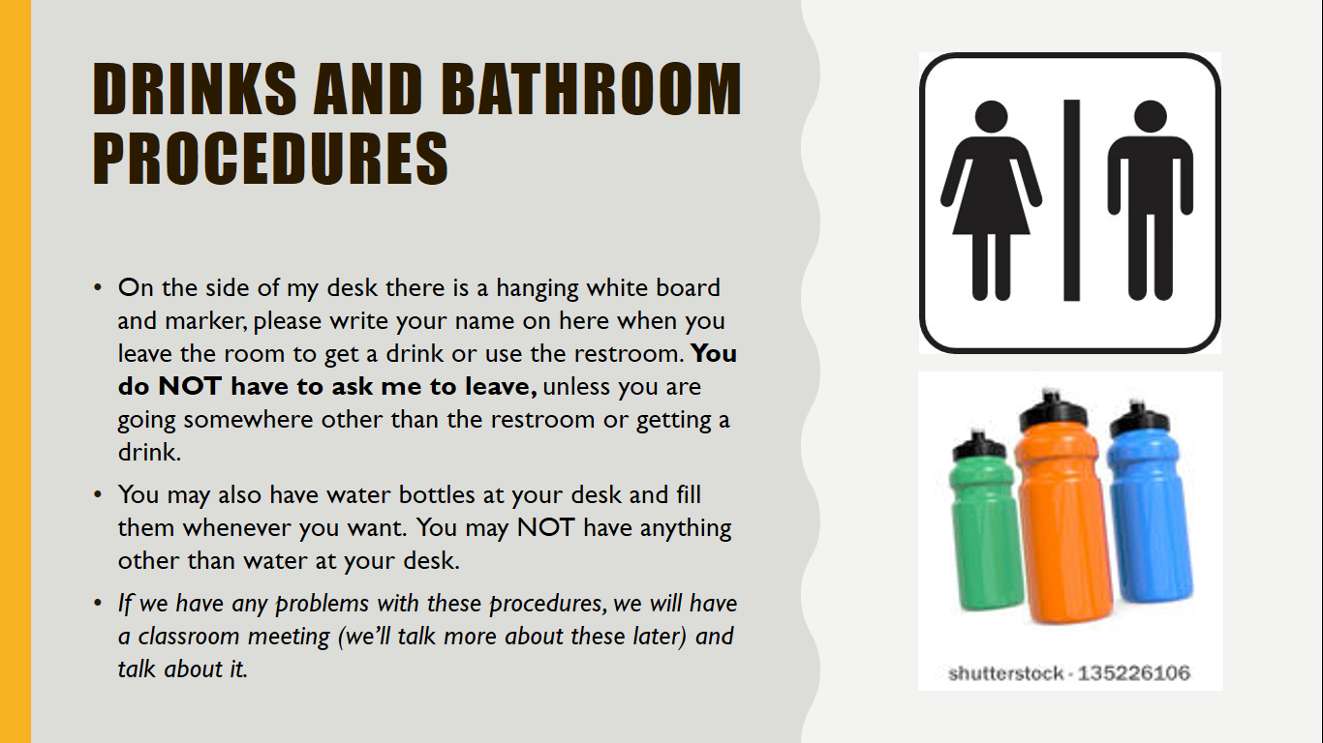

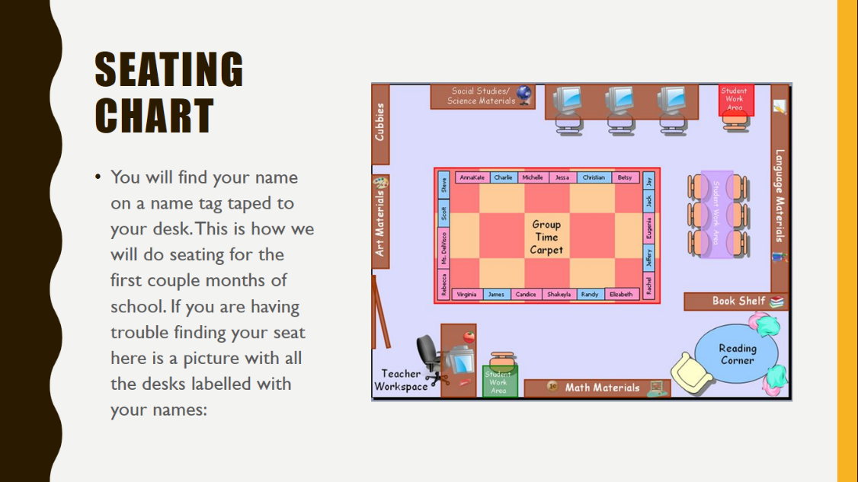

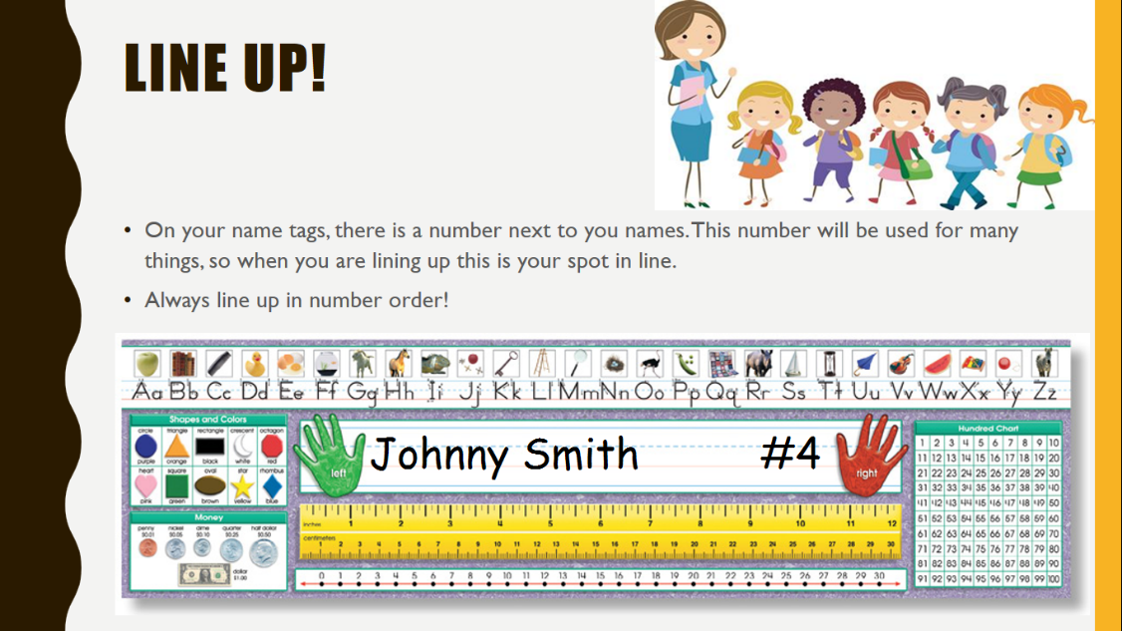

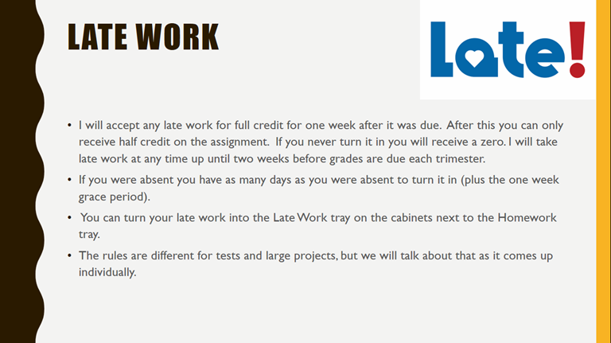

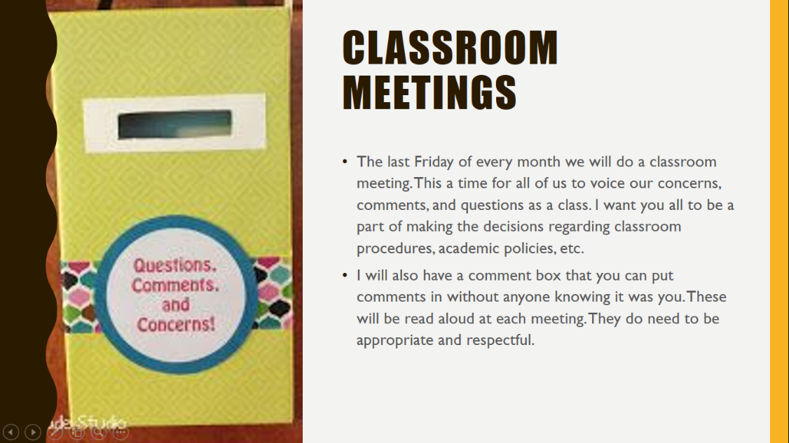
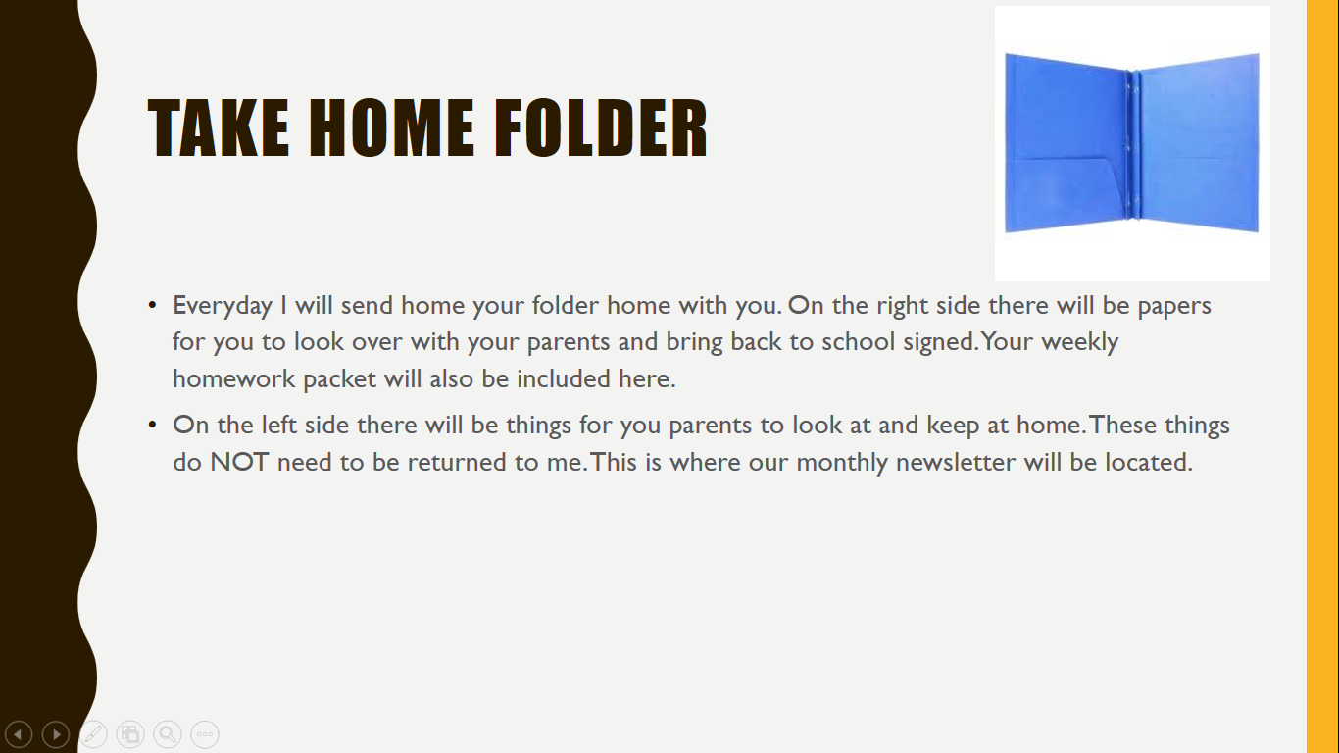
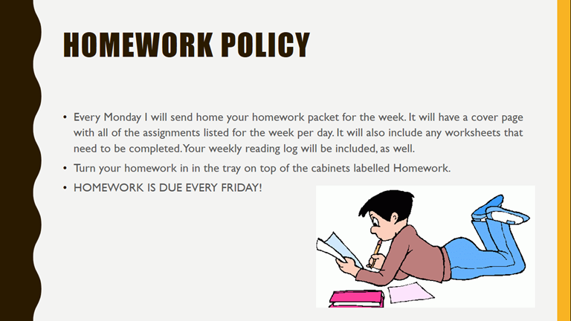

Appendix D

Common Core Standards
McKenna Walsh
University of Mary

Common Core Standards
Learn Why the Common Core Is Important for Your Child
The Common Core standards are intended to aid students as they prepare for their futures beginning in kindergarten and moving through 12th grade. They act as guidelines that consistently account for what each and every child should know and be able to do in both math and English. Teachers and experts have complied these standards across the United States to ensure students are ready for the workforce and college courses. The standards include and focus on the development of critical-thinking, problem-solving, and analytical skills. Another one of the standards’ purpose is to give educators a process to measure students’ progress and success.
It is important to note that no state’s standards were lowered to accommodate for the states whose students are not as successful. In fact, it has been clearly agreed upon that no state would lower its standards. Furthermore, it is beneficial to know that the standards were developed from the best in the country, the highest international standards, and evidence about educational outcomes.
Explore the Common Core
The Common Core Standards begin their focus on concepts and procedures from the beginning, which allows teachers plenty of time to teach them – and students to master them – throughout their educational careers. The standards are research-based, and not only does that mean many sources and articles have been used to contribute to them, but also that an abundance of educators, kindergarten through college, have also taken part in the formation of these standards. In order to produce the best possible outcome, these standards have been revised and rewritten several times.
The standards are grouped by grade level, beginning with K-8 and ending with 9-12, which is then grouped into grade groups: 9-10 and 11-12. Each standard is specific to its grade level and the goals that are part of completing that grade. Though these are specific and predetermined, the route teachers choose to teach these concepts is infinite. This aspect depends, of course, on the materials available to, abilities, needs, learning rates, and achievement levels of the students. The standards act as goals teachers need to help students achieve.
Understanding How the Common Core Was Created
In 2009, the development of the Common Core standards began using the best state standards already present, the knowledge of teachers, content experts, and leading thinkers, and comments and concerns from the public. There were separated into two parts: the college- and career-readiness standards (what is expected from students prior to high school graduation), and the K-12 standards (expectation for elementary school through high school). Teachers play crucial in the development of the standards. They served on Work and Feedback Groups for ELA and math standards and the National Education Association, along with many other organizations, were critical in bringing teachers together to present specific and constructive feedback. Following the conclusion of the development process, states began to voluntarily adopt the Common Core State Standards. In many, if not most, states the members of the school board formally accepted and adopted the standards. While in others the decision was made by the state superintendent of education, State Legislator, or governor. Currently, 42 states, D.C., and four territories have adopted the standards and are working on implementing them.

Appendix E
Interdisciplinary Unit Plan
Grade: 3
Unit Topic: The Ocean
Course/Discipline: Math, Science, Social Studies, Writing, Reading, and Art
Approximate Time Required: 2 Weeks
Main Purpose of the Unit Study:
Reading:
3. RL.3 Describe characters in a story (e.g., their traits, motivations, or feelings) and explain how their actions contribute to the sequence of events.
Writing:
3.W.2 Write informative/explanatory texts to examine a topic and convey ideas and information clearly.
b. Develop the topic with facts, definitions, and details.
Math:
3.MD.2 Measure and estimate liquid volumes and masses of objects using
standard units of grams (g), kilograms (kg), and liters (l). Add, subtract,
multiply, or divide to solve one-step word problems involving masses or
volumes that are given in the same units, e.g., by using drawings (such as
a beaker with a measurement scale) to represent the problem.
3.MD.4 Generate measurement data by measuring lengths using rulers
marked with halves and fourths of an inch. Show the data by making a line
plot, where the horizontal scale is marked off in appropriate units—whole
numbers, halves, or quarters.
Science:
3.4.3 Identify the needs of living things (e.g., food, shelter, soil, space,
water).
Art:
4.2.3 Use visual art structures and functions of works of art to
communicate ideas.
Social Studies:
3.1.3 Use a variety of resources (e.g. maps, charts, bar graphs, internet,
books) to gather information about people, places, and events.
Performance Objectives:
The student will be able to:
- Reading - describe the feelings of various characters in Rainbow Fish by Marcus Pfister.
- Writing - create their own “Who Will Win?” book including facts, definitions and details of the animal they chose.
- Math - measure the volume of an aquarium based on the measurements of an aquarium they have designed.
- Math - use a ruler to measure the dimensions of an aquarium they have designed.
- Science - identify the habitats and living conditions for marine life.
- Art - artistically create and design an aquarium including at least 3 types of marine life.
- Social Studies - use a variety of resources to compare and contrast two oceans.
Learning Activities:
- Reading
  - Read aloud Rainbow Fish
  - Character graphic organizer
  - Ocean books available for students to read
- Writing
  - Research/Select a marine life animal
  - Write 4-5 Sentences about their animal
  - Compare with 3-4 students to see “Who Will Win”
- Math
  - Teach length/width/height using a ruler
  - Teach volume based on their understanding of length/width/height
- Science
  - Research a marine life animal
  - Use a graphic organizer for habitat and living conditions for marine life animal
- Art
  - Show the different techniques used for painting
  - Paint aquarium and marine life animals
- Social Studies
  - Create a Venn Diagram
  - Discuss the different oceans
Assessment:
- Reading - informal formative assessment observe students’ understanding during whole group graphic organizer discussion
- Writing - students will create a “Who Will Win” book
- Math - measure the volume using length width and height of their aquarium
- Science - turn in graphic organizer for their chosen marine life animal
- Art - turn in their artistically designed aquarium
- Social Studies - informal formative assessment observing students’ understanding during Venn Diagram discussion

Appendix F
Technology lesson plan
Age Level: 3rd Grade
Subject(s) Area: Language Arts
Materials Needed: Laptop/iPad, camera, graphic organizers
Standards:
Write informative/explanatory texts to examine a topic and convey ideas and information clearly.
a. Introduce a topic and group related information together; include illustrations when useful to aiding comprehension.
b. Develop the topic with facts, definitions, and details.
c. Use linking words and phrases (e.g., also, another, and, more, but) to connect ideas within categories of information. d. Provide a concluding statement or section.
Objectives:
- Students will research the continent they were assigned in at least three of the following categories: clothing, animals, landforms, culture/people, etc.
- Students will create an expository text based on the information they have gathered from their research.
- Students will choose to present their information through a video (animated – using PowToon or real-life – using iMovie), photographs, brochure, or PowerPoint.
- Students will share their information with their peers, upcoming third graders, and their parents at Continent Showcase.
Learning Activities:
Opening Element: (Anticipatory set, setting a purpose for learning, assessment of background knowledge, Review, Etc.)
- Review continents, types of landforms, and oceans using Kahoot! online game.
- Review what expository writing is through discussion.
Technology:
- Kahoot! online game (use iPad, computer, or smart phone)
- Computer, camera or iPad for presentation of information
Required Vocabulary:
- Continent: A continent is defined as a large unbroken land mass completely surrounded by water, although in some cases continents are (or were in part) connected by land bridges. The seven continents are North America, South America, Europe, Asia, Africa, Australia, and Antarctica.
- Landform: A landform is a feature on the Earth's surface that is part of the terrain. Mountains, hills, plateaus, and plains are the four major types of landforms. Minor landforms include buttes, canyons, valleys, and basins. Tectonic plate movement under the Earth can create landforms by pushing up mountains and hills.
Instructional Methods:
- Begin by randomly assigning each student a continent. Explain that they may use books, articles, or websites to find information regarding their continent.
- Remind students they must choose three things to focus on about their continent (i.e., clothing, animals, landforms, culture/tradition, etc.
- Provide the students with graphic organizers to helps them keep track of their research facts.
Guided Practice Strategies
- Have students write a five-paragraph essay about their continent. These may be handwritten or typed
- Have students reread their essay to themselves and share it with two other people. Then, they should revise it based on their own and peers’ feedback. This time is must be typed
- Next, have student share the document with teacher. The teacher should call each student over and edit their essay with them, focusing on content – not so much grammar and spelling.
- Lastly, after the student revises again the teacher and student will visit again to edit grammar and spelling. After the last revision, they will have their finally draft.
Independent Concrete Practice/Application
- After the writing is complete students may then choose which way they would like to present their information for the showcase. Their options are a video (animated – using PowToon or real-life – using iMovie), photographs (taken by the students using a camera – NOT a smartphone), brochure (using the computer), or PowerPoint.
- At this point, the creativity and design is up to the students. However, the teacher should look over the students work periodically to ensure they are staying on track.
- Students must have teacher’s approval of their final draft prior to the day of the showcase.
Differentiation:
- This is lesson is differentiated by the various options students have to express what they have learned about their continent.
Wrap-Up:
- At the end of this project students will present their presentations at the Continent Showcase.
Assessment:
Formative:
- Observations of students’ content knowledge during Kahoot! game. (informal)
- Students essays and presentations (formal)

Appendix G
Purposes of Questions
Standard: 2.4.2 Identify various things that are found in different environments (e.g., cactus, lizard – desert; shark, coral- ocean)
- Getting interest and attention
  - What’s your favorite animal?
- Diagnosing and checking
  - What type of environment does this animal live in? / Where does this animal live?
- Recalling specific facts/information
  - What are some other things found in the ocean?
- Managing
  - Is everyone thinking of an animal and where it lives?
- Encouraging higher level thought processes
  - What kind of environments are hot?
  - What kind of environments are cold
  - Do you think it matters? Why?
- Structuring and redirecting learning
  - Now that we know what animals live where, what are some other things we can find in the ocean, desert, rainforest, etc.?
- Allowing expression of affect
  - Does anyone have any questions on environments and what things we find in them?

Appendix H
Levels of Questioning
Standard: 2.4.2 Identify various things that are found in different environments (e.g., cactus, lizard – desert; shark, coral- ocean)
- Knowledge
  - Identify things you find in the ocean, desert, rainforest, etc.
- Analysis
  - Summarize what you read when you researched an environment of your choosing.
- Comprehension
  - Apply your knowledge of things found in an environment of your choosing to create a story that takes there.
- Synthesis
  - Differentiate things you may find in the ocean versus things you may find in the desert.
- Application
  - Produce a diorama that depicts things found in the environment of your choosing.
- Evaluation
  - Justify how you know these things are found in your environment with research and background knowledge.

Appendix I
Direct instruction Lesson Plan
Age Level: 3rd grade
Subject(s) Area: Language Arts
Materials Needed: Lulu Wants to Grow Up passage, iPad
Standards:
3.RL.3 Describe characters in a story (e.g., their traits, motivations, or feelings) and explain how their actions contribute to the sequence of events.
Objectives:
Students will identify how character actions contribute to the sequence of events.
Learning Activities:
Opening Element:
- Read Lulu Wants to Grow Up aloud with class.
  - I read 1st paragraph, everyone reads 2nd, boys read 3rd, girls read 4th, I read 5th
Reflective Questions:
- Ask students what they think beginning, middle, and end of a story are. Do turn-and-talk.
- Talk with someone not sitting next to you about what they think was the beginning, middle, and end of the story.
Instructional Methods:
- Draw a graphic organizer on the white board.

BEGINNING | MIDDLE | END
- Setting  - Characters  - Actions | - Transition  - Identifies problem | - Resolution  - Reflection
- Lulu and her mother  - Tree branches on mountainside  - Wants to fly/grow up | - “A few days later…”  - Tried to fly away, slipped and fell | - Mother saves Lulu  - Doesn’t want to grow up anymore

- Fill out blue section first, explaining what the beginning, middle, and end each consists of.
- Ask students to look at their passage and think quietly what parts of the story goes in each section.
- Now fill out the orange section with students.
- Before filling out each part, the students should talk about it with their neighbor, or think about it. Then ask for volunteers or cold call for ideas to put in graphic organizer.
Guided Practice Strategies:
- http://smartyearsapps.com/service/sequencing/
- Students play sequencing game on iPads
Independent Concrete Practice/Application:
- Have students write a short story on the topic of their choosing. They must include a beginning middle and end.
- Have them type their stories on their iPads and highlight the beginning (yellow) middle (red) and end (blue) in different colors.
Differentiation:
- Auditory: read-aloud, turn-and-talk
- Visual: Graphic organizer
- Kinesthetic: iPad games, writing
Wrap-Up:
- Identify how each part of the beginning, middle, and end follow the characteristics we listed above.
- Ask students to give you a thumbs up, middle, or down on how correct their thoughts were of beginning, middle, and end when we talked about it immediately after reading story.
Assessment:
Formative:
- Observe during opening and guided practice comprehension of identifying what parts of the story are what. (informal)
- Review students’ stories and ensure they highlighted correctly. (formal)
Summative:
- Students will be able to take a test assessing where specific events of a story are part of the beginning, middle, or end.

Appendix J
Indirect Lesson Plan
Age Level: 3rd
Subject(s) Area: Math
Materials Needed: graduated cylinders (100 mL), liter containers (not labelled), pitchers
Standards:
Measure and estimate liquid volumes and masses of objects using standard units of grams (g), kilograms (kg), and liters (l). Add, subtract, multiply, or divide to solve one-step word problems involving masses or volumes that are given in the same units, e.g., by using drawings (such as a beaker with a measurement scale) to represent the problem.
Objectives:
Students will discover how many milliliters are in one liter.
Students will compare milliliters to liters.
Learning Activities:
Opening Element:
- Students will enter classroom and be instructed to grab supplies on the counter and get into assigned groups
  - Groups will be written on the board, along with a list of needed supplies
Technology:
- Students will communicate findings on a google doc and share it with teacher
Required Vocabulary:
- Liter
- Milliliter
- Graduate cylinder/beaker
- volume
Instructional Methods:
- Have a series of questions on board for students to use to guide them through the discovery process.
  - This should include steps similar to the following:
- Fill small cup labeled 1 mL with 4-5 drops of water.
- Now fill 100 mL beaker with water.
- How many times do you have to fill and dump this to fill the 1L container?
  - What does this mean (hint: how many mL are in 1 L)?
- Repeat this same process with the remaining containers. Be sure to record measurements (how much is in each container).
Guided Practice Strategies:
- Students should work on completing steps on the board with their group.
- The teacher is available for questions but should encourage discovery of their own.
- Students should type their conclusions, as a group, in a google doc that will be shared later.
Independent Concrete Practice/Application:
- Within math notebooks students will independently complete comparing questions and estimations of liters and milliliters.
Differentiation:
- Auditory: discussions within groups
- Visual: measuring water in containers
- Kinesthetic: pouring, measuring water in different containers
Wrap-Up:
- Go through everyone’s shared google doc and discuss everyone’s discoveries and conclusions
Assessment:
Formative:
- Observation during experimentation
- Google doc posts
- Work in math journal
Summative:
  - End of unit assessment about liters and milliliters

Appendix K
Ocean Unit Test
Name:_____________________ Date:_____________
READING
Answer the following questions true or false. Put a T for true and an F for false in the blank space provided.

_____ 1. The characters are introduced at the beginning of a story.
_____ 2. The conflict or problem is found at the end of a story.
_____ 3. We can look for a transition word (then or next) to tell us when we are in the middle of the story.
_____ 4. Character traits are who a character is on the inside – their personality. They are shown through what a character says or does.
_____ 5. Blue hair, red shirt and purple socks are examples of character traits.
Sort these parts/sentences from a story from beginning (first) to end (sixth). Write the letter on the line next to when that part of the story took place.
6. First: ______ a. Tom and Tess put the chips in the oven for 2 minutes.
7. Second: ______ b. They get out a plate to cook on.
8. Third: ______ c. Tom and Tess get out the nacho chips and cheese.
9. Fourth: ______ d. Tom and Tess eat the food.
10. Fifth: _____ e. They put chips on a plate.
11. Sixth: _____ f. They put cheese on the chips.
12. Seventh: _____ g. They take the nachos out of the oven.

MATH
Measure the following pictures using your ruler. Be sure to include your units in your answer. Measure in inches. Round your answer to the nearest fourth of an inch.

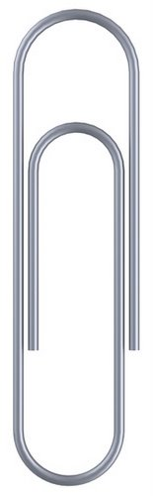
13.

____________________
14.
____________________

15.

__________________________
16.
___________________
Measure here
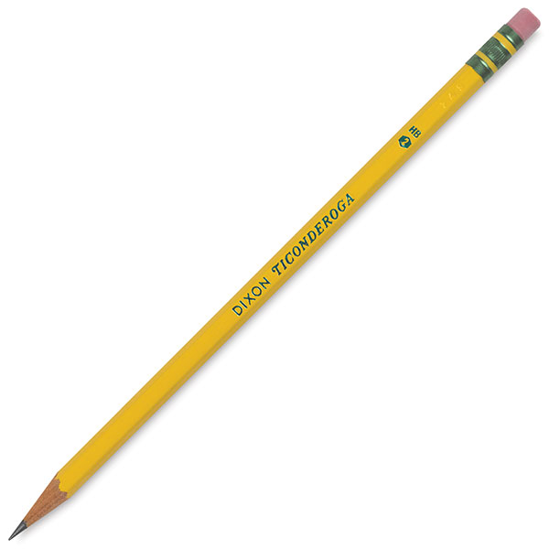
17.

__________________

SCIENCE
18. Dolphins eat ______.
a. squid
b. fish
c. shrimp
d. all of the above
19. The great white sharks only know predator is ______.
a. humpback whale
b. killer whale
c. hammerhead shark
d. The great white shark has no predators.
20. Which of these fish DO NOT live in the ocean?
a. Clownfish
b. Goldfish
c. Tuna
d. Stingray

SOCIAL STUDIES

21. Please write one paragraph (3-5 sentences) comparing two of the oceans you researched. You can use this space below to help you organize your thoughts. Remember to use proper grammar and spelling.

Ocean #1:_____________________

Ocean #2:____________________

Appendix L
Objectives | Knowledge | Comprehension | Application | Analysis | Synthesis | Evaluation | Total | Percent
Demonstrate an understanding of character traits. | 3 | 1 | 1 |  |  |  | 5 | 24%
Identify a sequence of events from beginning to end. |  |  | 7 |  |  |  | 7 | 33%
Measure various items using a ruler in inches. |  |  | 5 |  |  |  | 5 | 24%
Identify habitats and living conditions of marine life. | 3 |  |  |  |  |  | 3 | 14%
Compare and contrast two oceans. |  |  |  |  | 1 |  | 1 | 5%
Total | 6 | 1 | 13 | 0 | 1 | 0 | 21
Percent | 28% | 5% | 62% | 0% | 5% | 0% |  | 100%
Third Grade Ocean Unit Test Blueprint

